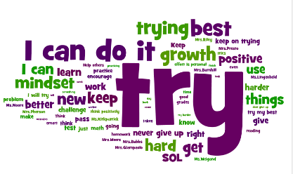

We’re going to carry on making sure that those children that need extra help to catch up are getting the best help possible so that they catch up even faster and children who need challenged in their learning have the support to do so! We will use assessment information as well as work completed in class to decide upon appropriate next steps and targets.

We want to make sure everyone has a voice at Luthermuir Primary and can take responsibility for additional things in school such as being a Pupil Council, Digital Leaders, ECO or RRS rep or JRSO. We would like to involve our parents and community as much as possible.

**What are we doing to improve our school this year?**

**2017-2018**

We are going to encourage children to read widely, explore a range of books and develop a love of reading by providing access to a variety of reading materials and opportunities to read for enjoyment. We will sign up for the First Minister’s Reading Challenge.

We want a more consistent approach to homework across the school which includes opportunities for developing the skills required for learning, life and work.

Teachers are going to continue to learn themselves and from each other to ensure the best outcome for all our learners. This year we will be looking specifically at Big Writing, Emergent Literacy and Number Sense.

We’re going to continue to promote a happy, healthy and active lifestyle through our daily mile and after school/lunchtime activities. Teachers are going to plan for more structured

opportunities to take learning in to the outdoor environment.

We want to make sure that everyone feels safe and happy at our school. We want children, staff and parents to feel supported, valued and listened to. We will do our best to make sure Luthermuir School is inclusive for all.

We will continue to encourage everyone to be involved in making decisions about their learning and tracking their own progress using appropriate benchmarks. Praise and rewards will be used more consistently to encourage and promote positive self-esteem.

We are going to help all learners to reach their full potential by encouraging growth mindset, resilience and perseverance, promoting a ‘can do’ attitude.

We are going to revisit our School vision, values and aims to make sure that everyone knows and understands what we hope for Luthermuir Primary School!